



Sexual Violence Prevention Worker
Dear Applicant

Thank you for your interest in joining WRASAC. This is an exciting opportunity to join our team and help shape the future of sexual violence prevention work across Dundee and Angus. We know that preventing sexual violence requires more than delivering workshops. It requires strong partnerships, meaningful engagement with young people and a commitment to creating lasting social change. We are looking for someone who is passionate about working with young people, committed to equality and social justice, and motivated to make a positive difference in their community. If that sounds like you, we would love to hear from you.

In this pack you will find the following documents: -

- Information about WRASAC
- Advice on completing your application form
- Job Description and Person Specification

Please note, all applications and relevant recruitment documents will be held confidentially and destroyed after 6 months, apart from documents relating to the successful applicant.

Your completed application should be submitted via email by sending it to recruitment@wrasac.org.uk.

Closing Date is Friday 14th August 2026

Invites to interview will go out Monday 17th August 2026

Interviews will be held Tuesday 25th August 2026

We look forward to receiving your completed application form. Enquiries about this position are welcome by phoning or emailing recruitment@wrasac.org.uk and someone will get back to you as soon as possible.

Yours sincerely
Katie Duff
Operations Manager

WRASAC, Ground Floor, 4 Chamber of Commerce Buildings, Panmure Street, DD1 1EP

Information about WRASAC

The Women’s Rape and Sexual Abuse Centre – Dundee and Angus (WRASAC) has been supporting survivors of rape, sexual abuse and exploitation and raising awareness about the damaging effects of sexual violence since 1984. We are a registered charity and a company limited by guarantee.

We provide a range of services to survivors of sexual violence, abuse and exploitation including:

Women’s Support Service including our Initial Referral Team
Dundee and Angus Young Survivors (DAYS)
Justice Advocacy Service
Prevention Work
Gender Based Violence (GBV) Team
Training and Awareness Raising
WRASAC Vision, Values and Strategic Priorities

Our Vision
For a world free from sexual violence, abuse and exploitation and a society in which everyone has equality, freedom and choices to live the lives they want and thrive.
Our Mission
To support survivors who have experienced any form of sexual violence, abuse or exploitation in their lives.
To promote equality and raise public awareness of the routes of sexual violence and its damaging and life-changing effects.

Our Values
We believe first and foremost that perpetrators of rape, sexual abuse and exploitation are responsible for their actions – not survivors.
We are a feminist organisation which means we recognise that all forms of rape, sexual abuse and exploitation are acts of violence, that disproportionately affects women and children, involving the abuse of power and control, are a breach of human rights and are fundamentally rooted in gender inequality.

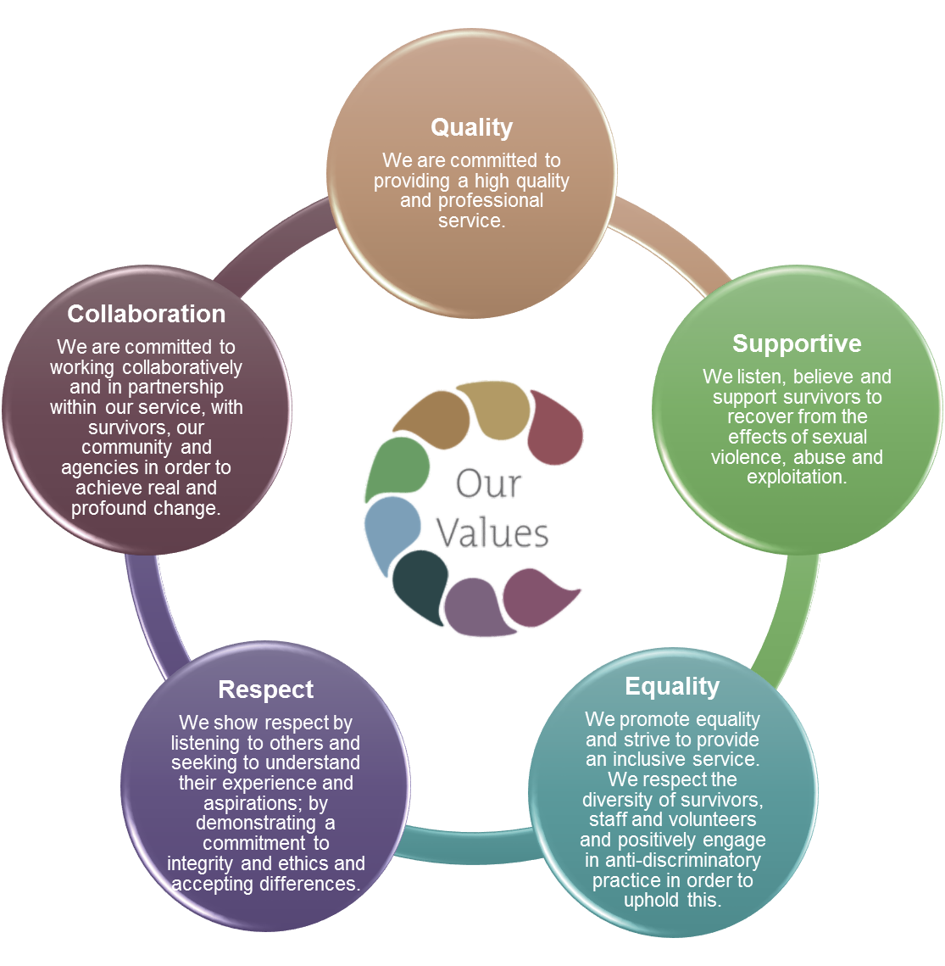

Our Strategic Priorities

SUPPORT FOR COMPLETING YOUR APPLICATION FORM
Thank you for your interest in joining WRASAC.
To ensure all applicants are treated fairly and consistently, shortlisting is based solely on the information provided in your application form. Please take time to complete each section fully, as we cannot make assumptions about your experience or consider information that has not been included.
Before You Start
Please carefully read:
- The Job Description
- The Person Specification
- Information about WRASAC and our values
These documents explain the duties of the post and the knowledge, skills, experience and abilities we will assess during shortlisting and interview.
Completing Section 4: Supporting Information
This is the most important section of your application and is where you demonstrate how you meet the person specification.
Please do not simply state that you have a skill or experience. Instead, provide clear examples that show:
- What you did
- How you did it
- Why you did it
- What the outcome was
Examples can come from:
- Paid employment
- Voluntary work
- Placements
- Education or training
- Community involvement
- Lived or transferable experience (where relevant)
Address the Person Specification
Applications are assessed against the criteria listed in the Person Specification.
We strongly encourage you to refer to each essential criterion and provide evidence of how you meet it. Applicants who clearly demonstrate how they meet the requirements are more likely to be shortlisted.
Word Count and Detail
There is no expectation that applications must be lengthy. However, applications that provide only brief statements without examples may not contain enough information for the panel to assess your suitability.
Please ensure you provide sufficient detail to demonstrate your knowledge, skills and experience.
Learn More About WRASAC
We encourage you to visit our website to learn more about our services, values and approach:
www.wrasac.org.uk

Important Information
- CVs submitted instead of the application form will not be accepted.
- Any CV submitted alongside the application will not be considered during shortlisting.
- This post is subject to PVG Scheme Membership and Non-Police Personnel Vetting.
- Completion of the Equal Opportunities Monitoring Form is voluntary and will not form part of the recruitment decision. The information helps us monitor the effectiveness of our commitment to equality, diversity and inclusion.
- Reasonable adjustments will be made throughout the recruitment process for candidates who require them.

Sexual Violence Prevention Worker

What We Offer:

Salary: £18,280 increasing to £19,678 after 1 year in post (FTE £30,467 increasing to £32,796)
Hours: 21 hours per week (Part time)
Funding: This post is currently funded until 31 March 2027. Continuation beyond this date is subject to future funding being secured.
Location: Dundee & Angus Outreach
Annual Leave: 38 days + 5 public holidays per year (FTE), increasing to 42 days + 5 public holidays after 4 years of service. (This will be pro rata based on a 21-hour working week.)
Pension: 6% employer contribution
Supportive & Inclusive Culture: Join a passionate, values-driven team working to create real change for survivors.
Reporting to: Operations Manager

Job Purpose The overall aim of this post is to deliver interventions to young people around healthy sexual relationships using the Rape Crisis Scotland sexual violence prevention pack, and to develop local strategic approaches to sexual violence prevention.

The main outcomes for this post are as follows:
- National and local strategic approaches to sexual violence prevention are more consistent and more effective.
- Strategic partnerships between rape crisis centres and local agencies are strengthened, promoting shared approaches to sexual violence and support for direct interventions by centres.
- Young people have increased knowledge and more positive attitudes towards sexual relationships, and less tolerance of violence.
- Young people have a greater role in shaping interventions in relation to sexual relationships.

Who we are looking for

We welcome applications from candidates with experience in youth work, community education, social care, violence against women services, education, mental health, advocacy or related fields. We recognise that candidates may not meet every desirable criterion and encourage applications from those with transferable skills and relevant values.
Main Duties
Delivery of prevention education
Deliver educational programs in schools and other education and community settings using the Rape Crisis Scotland sexual violence prevention pack. (Information Prevention | Rape Crisis Scotland)
Develop partnerships with schools and other education and training providers to plan education programs and to support the development of policy and practice in relation to sexual violence, in accordance with existing priorities such as Curriculum for Excellence, Getting it Right for Every Child and child protection.
Deliver information sessions to school staff and parents/carers as required.
Strategic development
Liaise with statutory and voluntary sector agencies (such as local education authority, youth and children’s services) and participate in multi-agency partnerships to develop strategic approaches to sexual violence prevention.
Liaise with Rape Crisis Scotland to increase connections and consistency between local and national approaches to prevention sexual violence.
Participate in practitioners’ forums with network of Rape Crisis prevention workers
Seek and develop opportunities for young people to be involved in shaping prevention interventions.

Support
Respond sensitively to disclosures and facilitate young people’s access to support services as appropriate.
Act on any child protection or wellbeing concerns identified during seminars according to the child protection policies and procedures. Where appropriate, participate in multi-agency initiatives to promote the young person’s safety and wellbeing.

Monitoring and Evaluation
Gather evaluation data from young people and link professionals using the materials in the Rape Crisis Scotland sexual violence prevention pack. Pass data to Rape Crisis Scotland to inform revision of materials and funding reports.
Contribute to any agreed evaluation procedures including external evaluations.

Equalities
Promote anti-discriminatory values and non-violence in all aspects of practice.

Accountability, supervision and professional development
Attend regular support and supervision with line manager.
Undertake training and development as required.
Adhere to center’s policies and procedures.

Team working and communication
Work as a team with other staff members
Attend regular team meetings and contribute to ongoing development within the organisation

Other
This job description is a broad picture of the post at the date of preparation. It is not an exhaustive list of all possible duties and it is recognised that jobs change and evolve over time. Consequently, this is not a contractual document and the post holder will be required to carry out any other duties to the equivalent level that are necessary to fulfil the purpose of the job.
Recruitment Process
The selection process for this role will include an interview and a presentation.
Candidates who are shortlisted will be provided with a presentation topic in advance of the interview and asked to deliver a short presentation (approximately 10 minutes) followed by questions from the interview panel.
The presentation is designed to assess communication, facilitation, subject knowledge and the ability to engage others with information relevant to the role.

Why Join WRASAC?
This is an opportunity to join a dedicated, feminist organisation working to create lasting change for survivors and young people across Dundee and Angus.

As a Sexual Violence Prevention Worker, you will play a key role in helping young people develop healthy, respectful relationships, challenge attitudes that contribute to violence, and influence future approaches to prevention work within local communities.

At WRASAC, we believe that supporting others starts with supporting our staff. We are committed to creating a supportive, compassionate and reflective working environment where staff are encouraged to develop, thrive and look after their own wellbeing.

We offer:
- Regular internal and external supervision, recognising the importance of reflective practice when working within the violence against women sector.
- Dedicated wellbeing time, including one hour of wellbeing time each month.
- Quarterly and annual wellbeing days, providing additional time for rest, reflection and self-care.
- Staff development time to support learning, growth and continuous professional development.
- Ongoing training opportunities to enhance your skills, knowledge and confidence in your role.
- Access to coaching, mentoring and professional support to help you thrive.
- A comprehensive staff wellbeing programme, including access to occupational health services and employee assistance resources.
- Peer support and networking opportunities, both within WRASAC and across relevant professional networks.
- Family-friendly policies that recognise and support different personal and caring responsibilities.
- Time Off In Lieu (TOIL) for approved additional hours worked.
- A generous annual leave entitlement and pension contribution.
- The opportunity to work as part of a passionate, supportive team committed to social justice, equality and ending violence against women and girls.
WRASAC is committed to promoting equality, diversity and inclusion and welcomes applications from women from all backgrounds and communities.
- Please note that this post is open to women only under Schedule 9, Part 1 of the Equality Act 2010

What Makes This Role Unique?

While delivery of relationship and sexual violence prevention education is a core part of this role, the post offers opportunities to contribute to wider systems change across Dundee and Angus. The successful candidate will build relationships with schools, community organisations and strategic partners to influence local approaches to prevention. They will be encouraged to identify opportunities to develop prevention work, contribute to workforce development, support policy and practice discussions and involve young people in shaping future approaches.

The role requires creativity, initiative and the ability to adapt approaches to meet the needs of different settings while maintaining the integrity of the national Rape Crisis Scotland Prevention Programme.

A Word from the Prevention Worker

"One of the things I've valued most about this role is the opportunity to influence prevention work beyond direct delivery. Alongside working with young people, I've been able to build partnerships, contribute to local developments, create training opportunities and help shape how prevention is approached across Dundee and Angus. The role offers a great balance of direct practice, relationship building and wider systems change."

PERSON SPECIFICATION

CRITERIA |  | ESSENTIAL |  | DESIRABLE
Knowledge | E1  E2  E3  E4  E5 | Understanding of feminist analysis of violence  against women  Thorough knowledge of issues relating to sexual violence  Understanding of the impact of sexualisation of young people in the media and links with violence against women  Understanding of trauma and trauma-informed approaches when working with young people. And the ability to apply trauma-informed principles in practice.  Understanding of child protection, safeguarding and wellbeing responsibilities when working with children and young people. | D1  D2  D3 | Knowledge of approaches to sexual violence prevention  Knowledge of current legislation, policy and strategy relating to education and to the violence against women agenda  Knowledge of contemporary issues affecting young people, including online harms, digital misogyny and harmful online communities
Skills and Abilities | E6  E7  E8  E9  E10  E11  E12  E13  E14 | Ability to engage with young people in a range of settings.  Experience of working within child protection and adult protection frameworks.  Ability to work effectively with a wide range of partners in voluntary and statutory agencies.  Excellent written and verbal communication skills, including report writing, presentation delivery and communication with a range of audiences.  Ability to organise and prioritise your own workload and schedule.  Ability to facilitate sensitive discussions on topics including consent, sexual violence, relationships and gender  Excellent interpersonal and relationship-building skills, with the ability to establish and maintain effective relationships with young people, professionals and partner organisations  Competence in use of IT, for example Word and Excel programs, email and internet and delivery of PowerPoint presentations  Ability to monitor, record and report on project outcomes.
Experience | E15  E16  E17  E18 | Experience of delivering workshops/groupwork to young people  Experience of responding appropriately and sensitively to disclosures, or the ability to demonstrate transferable skills in managing disclosures and safeguarding concerns.  Experience of involving young people in the design, delivery or evaluation of services or interventions.  Experience and ability to work independently in an outreach capacity | D4  D5  D6  D7  D8  D9  D10 | Experience of developing educational materials or groupwork program  Experience of working with people affected by gender-based violence  Experience of working independently in an outreach capacity  Experience of developing and maintaining multi-agency partnerships.  Experience of evaluating interventions aimed at young people  Experience of adapting learning or educational approaches to meet the needs of different audiences and settings  Experience of designing and delivering training or learning opportunities for professionals, community groups or partner organisations.
Qualifications |  |  | D11 | Qualification in Mental Health, Social Care, Community Education, Youth Work or similar discipline
Other | E19  E20  E21 | Access to vehicle, business insurance and full driving licence (All subject to DVLA checks)  Able to work flexibly and to undertake some evening and weekend work.  Understanding of equality, diversity and inclusion principles and their application when working with young people and communities.
Application

Post Applied For:

1. Personal Details

First Name only | Contact information:  Mobile:  Email:

2. References
Please provide details of a minimum of two referees, one of which must be your most recent employer.

Name:

Email address or Telephone number:
Relationship to you:

Name:

Email address or Telephone number:
Relationship to you:

- Period of notice required by current employer?

- Are there any dates when you will be unavailable for interview?

- WRASAC is committed to creating an inclusive recruitment process. If you are invited to interview and require any adjustments, support or alternative arrangements, please let us know below. We welcome requests for reasonable adjustments and will work with you to ensure the recruitment process is as accessible as possible.

- Are there any restrictions to your residence in the UK, which might affect your right to take up employment? If Yes, please provide details

- If you are successful in your application will you require a work permit prior to taking up employment?

- Do you hold a full drivers licence? Yes/No (please check information to see if this is essential for a role)

- Do you currently have car insurance for business use? Yes/No
If no, then we would need you to get this set up before starting employment if successful.

Notes-

- Are you related to any employee or board member of WRASAC Dundee and Angus? Yes / No If yes, please provide details:

- Are you or have you ever been a member of WRASAC Dundee and Angus Board of Directors? Yes / No If yes, please provide details:
- Where did you see this vacancy advertised

Data Protection Statement
The information that you provide on this form and that obtained from other relevant sources will be used to process your application for employment.

The personal information that you give us will also be used in a confidential manner to help us monitor our recruitment process. If you succeed in your application and take up employment with us, the information will be used in the administration of your employment with us and to provide you with information about us or third party via your payslip. We may also use the information if there is a complaint or legal challenge relevant to this recruitment process.

We may check the information collected, with third parties or with other information held by us. We may also use or pass to certain third parties information to prevent or detect crime, to protect public funds, or in other ways as permitted by law.

By signing the application form we will be assuming that you agree to the processing of sensitive personal data, (as described above), in accordance with our registration with the Data Protection Commissioner.

DECLARATION
I declare that to the best of my knowledge and belief the information given is correct and complete. I understand that WRASAC reserves the right to withdraw the offer of employment or to terminate employment already commenced if the information given to us is inaccurate or misleading in any way. Any job offer is conditional upon receipt of satisfactory references and, if required by WRASAC, any medical reports or disclosure check.

Signed
Date

Work Experience – Starting with most recent employer
Please continue on additional sheets if necessary.

Post:

Address:
From: To:
Main Duties:

Reason for leaving:

Post:
Address:
From: To:
Main Duties:

Reason for leaving:

Employment Continued for the last 5 years minimum (please let us know if you have had any gaps in employment and if so please note why)

Dates from to | Employers name and address | Post title, responsibilities, experience gained, key achievements | Reason for Leaving, Salary

Membership of professional bodies

Educational, Technical & Professional Qualifications

Institute | Qualification gained | Date Achieved
- Please explain how your knowledge, skills and experience meet the essential and desirable criteria listed in the Person Specification. We recommend using specific examples and describing the actions you took and the outcomes achieved.

Applications that do not provide sufficient evidence may not be shortlisted.

Your completed application should be submitted via email by sending it to recruitment@wrasac.org.uk

